Use Case

This application is aiming to help users to manage their money by entering date, amount of money and declaring of spending. Users can also review the history of transaction and the current balance.

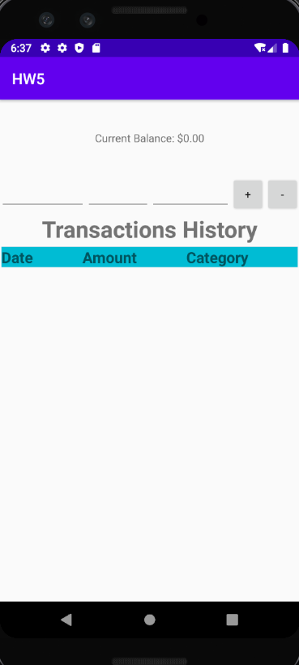

First step: Users enter the date of the transaction

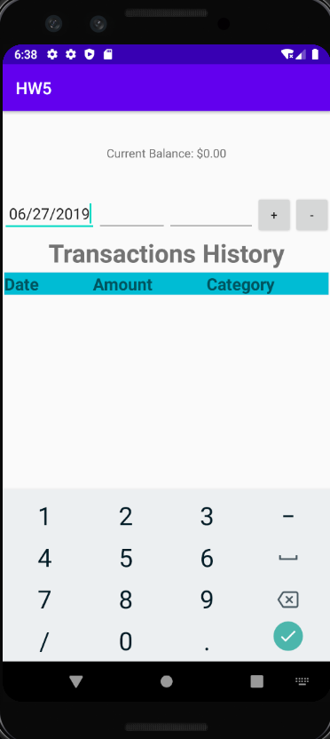

Second step: Users enter amount of money

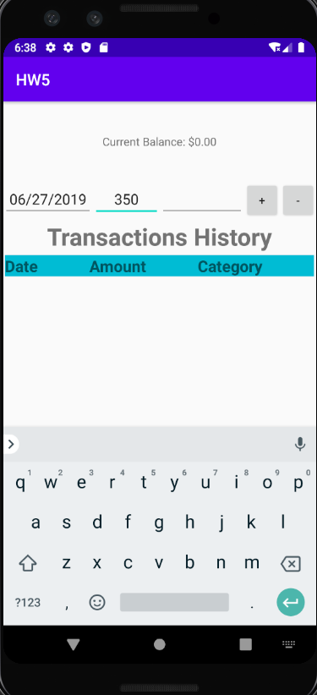

Third step: Users enter the declaring of money

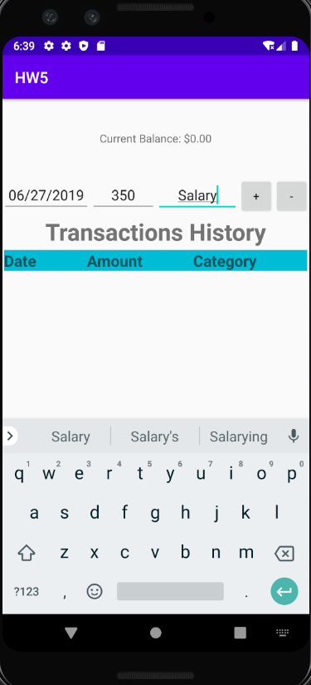

Fourth step: users decide if the transaction is a deposit or spending and clicking “+” or “-”

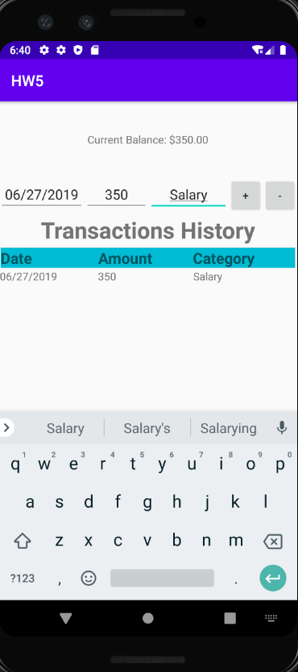

In the end, the users can review the balance and the transaction history